Name Zahid Mursleen
Roll No 24F-0593

TASK 1
#include <iostream>
using namespace std;
int main()
{
int amount;
char transaction = 'y'; // Ask if user want to make another transaction
while (transaction == 'y' || transaction == 'Y')
{
cout << "Enter amount to withdraw (1000 - 10000):";
cin >> amount;
if (amount >= 1000 && amount <= 10000) // For valid amount
{
cout << "You successfully withdraw " << amount << " money" << endl;
}
else
{ // For invalid amount
cout << "You entered an invalid amount of money (Range : 1000 to 10000)" << endl;
continue; // To skip the remaining statements
}
// Ask if user want to make another transaction
cout << "Would you like to make another transaction (N/Y): ";
cin >> transaction;
}
cout << "Thankyou for visiting the ATM, Goodbye" << endl;
return 0;
}

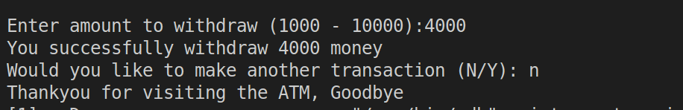

TASK 2
// Input a number form user
// and print table of that number

#include <iostream>
using namespace std;
int main()
{
int num;
cout << "Enter a number to print table:";
cin >> num;
int i = 1; // Counter variable
while (i <= 10) // print table up to 10
{
// Printing table
cout << num << " X " << i << " = " << num * i << endl;
i++;
}
return 0;
}

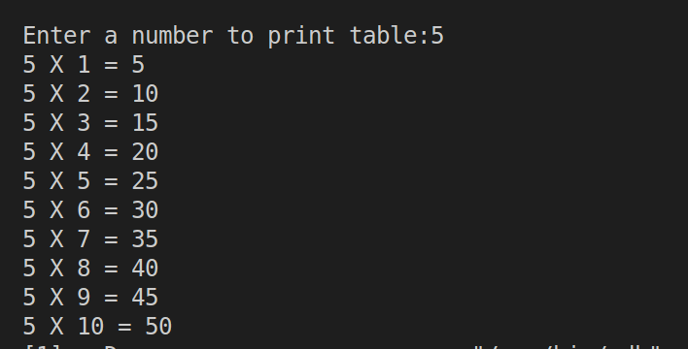

Task 3
// Taking marks of exam from user until
// user enter a -ve value
#include <iostream>
using namespace std;
int main()
{
float marks, sum = 0, avg;
int i = 0;
cout << "Enter your exam marks: ";
cin >> marks;
while (marks >= 0) // check marks should be +ve
{
//sum of marks
sum = sum + marks;
cout << "Enter your exam marks: ";
cin >> marks;
i++; // count number of iterations
}
//Calculate avg
avg = sum / i;
cout << "You total avg marks = " << avg << endl;
return 0;
}

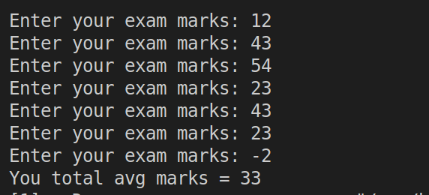

TASK 4
#include <iostream>
using namespace std;
int main() {
int number, originalNumber, remainder, reversedNumber = 0;
bool isPalindrome = true;
cout << "Enter a number: ";
cin >> number;
originalNumber = number; // Store the original number
// Reverse the number using a loop
while (number != 0) {
remainder = number % 10; // Get the last digit
reversedNumber = reversedNumber * 10 + remainder; // Append it to the reversed number
number /= 10; // Remove the last digit from the original number
}

// Check if the original number matches the reversed number
if (originalNumber != reversedNumber) {
isPalindrome = false;
}
if (isPalindrome) {
cout << originalNumber << " is a palindrome." << endl;
} else {
cout << originalNumber << " is not a palindrome." << endl;
}
return 0;
}

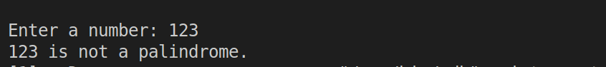

TASK 5
// Calculate sum of numbers( min. 5)
// until user enter a -ve number
#include <iostream>
using namespace std;
int main() {
int i= 1;
int count = 0;
int number;
int sum = 0;
cout << "Enter at least " << 5 << " numbers to calculate their sum.\n";
cout << "If you enter a negative number, the program will terminate.\n";
while (count < 5) {
cout << "Enter number " << i << ": ";
cin >> number;
if (number < 0) {
// Break the loop if a negative number is entered
cout << "Negative number entered. Terminating the loop.\n";
break;
}
// Add the number to the sum
sum += number;
count++;
i++;
}
// Output the sum
cout << "Sum of the entered numbers: " << sum << endl;
return 0;
}

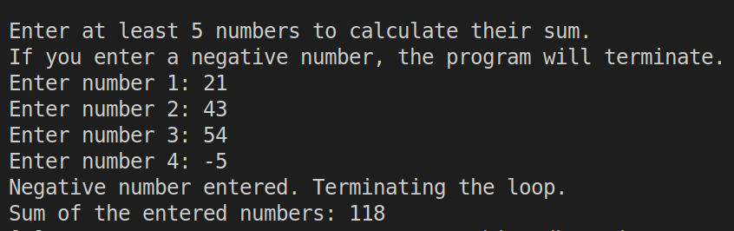

TASK 6
#include <iostream>
using namespace std;
int main() {
int i = 1; // Counter for numbers entered
int number;
int sum = 0;
cout << "Enter at least " << 5 << " numbers to calculate their sum.\n";
while (i <= 5) {
cout << "Enter number " << i << ": ";
cin >> number;
if (number < 0) { // Skip adding negative numbers
continue;
}
// Add the number to the sum
sum += number;
i++;
}
cout << "Sum of the entered numbers (ignoring negatives): " << sum << endl;
return 0;
}

